GlobalSight Developer Guide
Summary
This document will:
- Describe a request lifecycle and how to develop a feature. (Section 1)
- Introduce configurations in GlobalSight system. (Section 2)
- Explain installation process. (Section 3)
- Introduce the desktop icon program. (Section 4)

Client request lifecycle
Typically, a client request lifecycle covers almost all core flow chart of GlobalSight system. Drawing 1 shows the summary sequence of a common request lifecycle.
When a request comes, the container will choose the corresponding servlet to handle it. And then the servlet will look up the configuration file to find the page handler for this special request. A page handler will collect necessary parameters from request, and pre-validate them before dispatch the request data to the real business handler or manager which will be found from the ServerProxy. The core business operation will be done in the real handler or manager, including cooperation with database.
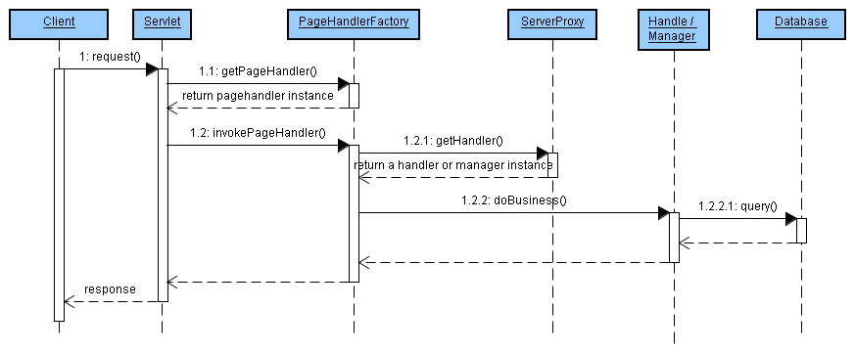Drawing 1: Summary sequence
Take operation of creating a company as an example to show how to implement a feature in GlobalSight system. The steps will according to the previous summary sequence, and the detail sequence draw of creating company is draw 2.
Following sections will describe the details of each step.
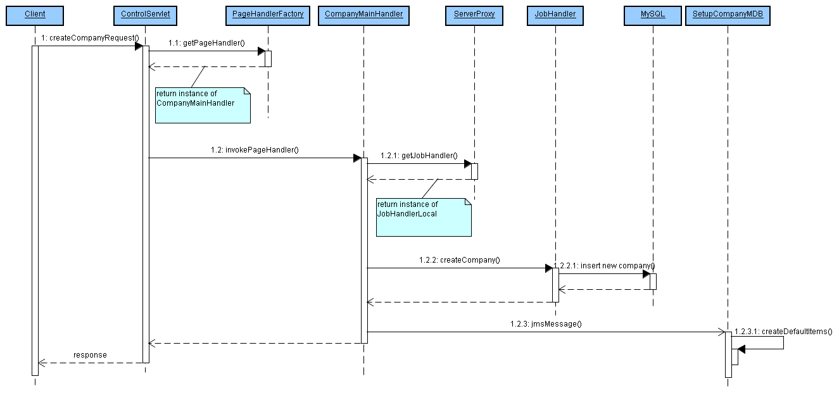Drawing 2: Create company sequence
- Request of creating a company
You can send a request of creating a company from the web page if you can login as super company administrator. Forward to “Setup --> Company” and click the button “new”. Input new company name and description, then submit it.
The request will be sent to our server. The most important thing you need to pay attention to is the URL string. It is like this :
http://localhost/globalsight/ControlServlet?linkName=save&pageName=COM2&action=create
Remember it, you will need to analyze it for the later operation.
- Find corresponding servlet
From the URL, you can find out that this operation should be handled by ControlServlet which is a core servlet handling mostly requests.
There are other servlets declared in the web.xml.template file, such as ReportServlet, CapImportServlet and etc. (main6\envoy\src\web.xml.template, About template file information, please refer to section 3.)
- Look up page handler
Servlets' responsibility is dispatching request to special page handler. The mappings between request and special page handler class are set in the configuration file EnvoyConfig.xml (main6\envoy\src\java\resources\EnvoyConfig.xml).
Take a look of the configuration of company module:
<WebModule webModuleName="companies">
<WebActivity webActivityName="companies">
<WebPage pageName="COM1" isDefault="true" jspName="/envoy/administration/companies/companyMain.jsp" pageHandlerClassName="com.globalsight.everest.webapp.pagehandler.administration.company.CompanyMainHandler">
<PageLink linkName="new1" destinationPageName="COM2"></PageLink>
<PageLink linkName="modify" destinationPageName="COM2"></PageLink>
<PageLink linkName="remove" destinationPageName="COM1"></PageLink>
<PageLink linkName="self" destinationPageName="COM1"></PageLink>
</WebPage>
<WebPage pageName="COM2" isDefault="false" jspName="/envoy/administration/companies/companyBasic.jsp" pageHandlerClassName="com.globalsight.everest.webapp.pagehandler.administration.company.CompanyBasicHandler">
<PageLink linkName="cancel" destinationPageName="COM1"></PageLink>
<PageLink linkName="save" destinationPageName="COM1"></PageLink>
</WebPage>
</WebActivity>
</WebModule>
About the detail of this configuration file please refer to section 2. Following will explain how to analyze the URL and find out the page handler.
Often there are two parameters named “pageName” and “linkName” in the URL. The page name specified the current page name and the link name specified where to go from current page.
Look around creating company URL, page name is “COM2”, you can find the same page name in second web page node. The link name is “save”, so look up this name in the page link of the second web page node. You can find it at the last page link, and the destination name is “COM1” which refers to the first web page node. Actually, this URL points to the first web page node. So the page handler of this request must be the page handler defined in the first web page node – CompanyMainHandler.
Servlet will look up the configuration mappings by request parameters to find out the page handler. All page handlers will be created by PageHandlerFactory and contained in a map for reusage.
- Invoke page handler
Each page handler need to extends class PageHandler, and rewrite the invokePageHandler method if necessary. Servlets will invoke the invokePageHandler method to handle the request and return the response to client.
- Get real handler
The responsibility of page handler is pre-validating the parameters and prepare necessary information for solve the request. The real business logic will be handled in a handler or manager which can be found from the ServerProxy. Such as creating company request will be handled by the JobHandler.
- Solve business logic
The core business logic should be done in the handler or manager. Handler and managers can query from database, insert new data and do any other necessary operation to solve the request.
- Asynchronous operations if necessary
Creating company request will trigger a JMS message to create default items for new company if the company is created successfully.
GlobalSight system use JMS to do the asynchronous operations if necessary.
Implement a new feature should be similar as creating company process.
- Define a mapping of page name and page handler class in the configuration file.
- Create a sub class of PageHandler
- Dispatch the request to the real handler or manager to solve the business.
- (Create a message driven bean to handle the asynchronous operation if necessary.)

Configuration
- EnvoyConfig.xml file
EnvoyConfig.xml file defines the mappings between page name and handler class.
  - WebApplication
WebApplication the root node of envoy configuration file.
It can contain one or more WebModules.
Property Name | Description
webAppName | Define a web application name.

  - WebModule
This node only can be written inner WebApplication target.
It can contain one or more WebActivities.
Property Name | Description
webModuleName | Define a web module name.

  - WebActivity
Sub node of WebModule. It can contain one or more WebPage.
Property Name | Description
webActivityName | Define a web activity name.

  - WebPage
WebPage defines the mapping relationship amount JSP file, page name and handler class. It is sub node of WebActivity and con contain zero or more PageLinks.
Property Name | Description | Note
pageName | Define a page name. | This will be used to specify this page.
isDefault | Default flag. | All web pages in one web activity need and only can have one web page set to true.
jspName | Associate with a JSP file. | The path of JSP file.
pageHandlerClassName | Specify the handle class. | The page handler which will handle the special request.

  - PageLink
PageLink defines the forward path between web pages. If the page name and link name are matched, the request will be forwarded to the destination web page to be handled.
Property Name | Description
linkName | Define a link name to forward.
destinationPageName | Specify the destination web page name.

- Other configurations
The following will list out the configuration files for the special technology. About how to configure them, please refer to each web page for detail.
- JMS
File name | Path
ejb-jar.xml | main6\diplomat\dev\src\java\com\globalsight\cxe\adaptermdb\
jboss.xml | main6\diplomat\dev\src\java\com\globalsight\cxe\adaptermdb\

- jBPM
File name | Path
jbpm.cfg.xml | main6\envoy\src\java\
hibernate-jbpm.cfg.xml.template | main6\envoy\src\java\

- Hibernate
File name | Path
hibernate.properties.template | main6\envoy\src\java\
hibernate.cfg.xml | main6\envoy\src\java\
Mapping files | main6\envoy\src\java\com\globalsight\persistence\hibernate\xml\

- SQL files
File name | Path
SQL files | main6\envoy\schema\mysql\

- JBoss
File name | Path
Jboss server | main6\tools\j2eeVendor\jboss\jboss_server\
Configuration files | main6\tools\j2eeVendor\jboss\util\

- Quartz
File name | Path
quartz.properties.template | main6\envoy\src\java\

Installation process
Installation process is a standalone program with no dependence of GlobalSight system, but it is still very important for GlobalSight system. This process will communicate with end user to set many important configuration properties. The following explains how the process works with the property files.
- Property files' relationship
The whole install process depends on the property files, including how many pages need to show, what the display sequence is, how many parameters will be shown on each page and what the parameters' types, etc. Most of the information is defined in the property files. See the following table for details.
All the property files are in “main6/tools/install/data/” directory.
File name | Description
installOrderUI.properties | The property “screen_list” defines the screen sequence.  Each screen name in the property “screen_list” should have a separate property to define the parameters and sequence on the screen itself. The parameters are separated by comma symbol.
installValueTypes.properties | This file defines the parameter's value type and input way.  Select one parameter name from the above property file. Use the name to find the property, the value is this parameter's value type. Such as “checkbox” means string, and input by text field.
installDisplay.properties | This file defines the parameter's label name.  The parameter's name is still found from the first property file. Use the name to find the property in this file. The value will be used as label name in the screen.
installDefaultValues.properties | This file defines the parameter's default value.  The first time to run installation process, this value will be set to the specified parameter whose name matches the property name.
installAmbassador.properties | This file contains some display sentence and page tiles which will be used by special screen.
installUI.properties | This file contains some common screen properties and button names.

- Template files
Template files are special files which will be recreate after installation process. Template files contain unknown parameter's value which will be set during installation process. So the installation process will replace the unknown parameter by the input value.
The unknown parameter is in special pattern like “%%KEY%%”. The “KEY” must be the same in “installOrderUI.properties” file, and double “%%” symbol covers the key name will tell the installation process to replace the value between them.
You can add your own template files in the Install.java file. Specify the path and name of template file and the path and name of new file, then installation process will do this at the end of process.

Desktop Icon
Desktop icon is an extended tool for GlobalSight system, designed to simplify tasks such as submitting and retrieving projects from GlobalSight. It does this more quickly and easily than the browser-based GlobalSight application. It utilizes the web services API which GlobalSight provides.
About how to install and use it, please refer to the GlobalSight desktop icon user guide. (You can get it from globalsight web page www.globalsight.com)
The following will use “desktop_home” to refer to the directory “main6/envoy/src/webserviceClients/ambassador-desktop/desktopicon”. This is the root directory for desktop icon.
- Source code.
All the source codes are in the directory “desktop_home/src/”. They are separate from GlobalSight system, so you can develop them without the whole GlobalSight system.
- Build
If you want to build a whole desktop icon client, open a command window and forward to the directory “desktop_home/tools”, use the following ant script to build it:
A zip file named “DesktopIcon.zip” will be created in the directory “desktop_home/build”, if the target is successful. This zip file contains all the necessary files for installing and executing desktop icon.
ant make.package

- Patch
If a desktop icon has installed already, you can use ant target “make.app” to build the desktop icon program. Both of using the ant script or executing the batch file “ant.make.app.bat” in “desktop_home/tools/” folder can do this. A new directory named “DesktopIcon” will be created under the desktop icon root directory. This folder contains all the same files in the built zip file. Copy the “desktopicon.jar” to installation path of the existing desktop icon client. Replace the old jar file in installation root path.

